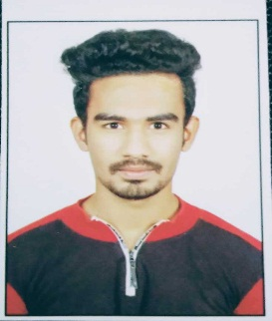FULL NAME: SANMIT PANKAJ VARTAK

Email id: sanmitvartak.sv@gmail.com

CONTACT NUMBER: 9834702809

SPECIALIZATION: Software Development

HackerRank: sanmitvartak_sv1

**CAREER OBJECTIVE:**

* To secure a challenging **position** in a reputable organization to expand my learnings, knowledge, and skills.
* Secure a responsible **career** opportunity to fully utilize my training and skills, while making a significant contribution to the success of the company.

**ACADEMIC PROFILE:**

|  |  |  |  |  |
| --- | --- | --- | --- | --- |
| DEGREE | INSTITUTION/SCHOOL | BOARD | YEAR | PERCENTAGE |
| 10th | New English School, Vasai | SSC | 2014 | 87.4 |
| Diploma in Computer Engineering | Government Polytechnic, Mumbai | Autonomous Institute | 2017 | 83.26 |
| Bachelor of Engineering in Computer Science | Rajiv Gandhi Institute Of Technology | Mumbai University | 2020 | 65.01 |

**PROJECTS:**

**INTERNSHIP PROJECTS:**

**Greenbappa ->** Commercial website greenbappa.ml for selling eco-friendly ganpati idols.

**Olcademy ->** Developing online learning website olcademy.in with features like SSO and wallet.

**BE PROJECT:** Prediction of cyber bulling incident in a media based social network .

**ACTIVITIES:**

* **Positions of Responsibility**
* Leading a team with motivation.
* **Extra-Curricular Activities**
* Participated in sports of college such as Kabaddi, Kho-Kho, etc.

**SKILL SETS:**

Coding in C, Java, Python, SQL, HTML, CSS, JavaScript, JQuery, Ajax, JSON.

**HOBBIES:**

Coding, Gym and fitness, Football, Gaming, etc.